**A PROJECT REPORT**

**ON**

**HARMONIZING THE FUTURE: PROGNOSTICATING SPOTIFY MUSIC SKIPS ACTION PREDICTION WITH MACHINE LEARNING**

Submitted to

**Amity University, Noida**

In partial fulfilment of requirements for the award of the degree

Bachelor of Technology

On

Computer Science and Engineering

By

**MOHAK BHATIA**

**A2305221034**

Under the guidance of

**Dr. M ParthaSarathi**

**CSE Department, ASET**

**DEPARTMENT OF COMPUTER SCIENCE AND ENGINEERING AMITY SCHOOL OF ENGINEERING AND TECHNOLOGY AMITY UNIVERSITY, UTTAR PRADESH**

## **DECLARATION**

## I, **MOHAK BHATIA,** student of B.Tech CSE, hereby declare that the project titled **“HARMONIZING THE FUTURE: PROGNOSTICATING SPOTIFY MUSIC SKIPS ACTION PREDICTION WITH MACHINE LEARNING ”,** which is submitted to Department of Computer Science and Engineering, Amity School of Engineering and Technology (ASET), in partial fulfilment of requirements for the award of the degree Bachelor of Technology in Computer Science and Engineering, has not previously formed the basis for the award of any degree, diploma or any other similar title or recognition. The author attests that permission has been obtained for the use of any copyrighted material, brief excerpts of which have been used in her dissertation/project report. The use of all such material in the scholarly writing has been duly acknowledged under Bibliography and References. I hereby declare that I have gone through project guidelines including policy on health and safety, policy in plagiarism etc.

Noida

Date:

i

**MOHAK BHATIA**

**A2305221034**

## **CERTIFICATE**

On the basis of the declaration submitted by **MOHAK BHATIA** student of B.Tech CSE, I hereby certify that the project titled **“HARMONIZING THE FUTURE: PROGNOSTICATING SPOTIFY MUSIC SKIPS ACTION PREDICTION WITH MACHINE LEARNING”** which is submitted to Amity School of Engineering and Technology, Domain of Engineering and Technology, Amity University Uttar Pradesh, in partial fulfilment of the requirement for the award of the degree of Bachelor of Technology (Computer Science and Engineering), is an original contribution with existing knowledge and faithful record of work carried out by him under my guidance and supervision.

To the best of my knowledge this work has not been submitted in part or full for any Degree or Diploma to this University or elsewhere.

Noida

Date

**Dr. Abhishek Singhal**

**Associate Professor**

**Amity School of Engineering and Technology**

**Domain of Engineering and Technology**

**Amity University Uttar Pradesh**

## **ACKNOWLEDGEMENT**

It is a high privilege for us to express our deep sense of gratitude to the entire faculty members who helped me in the completion of the project, especially our guide Dr. M ParthaSarathi who was always there at hour of need.

Our special thanks to all other faculty members, batch mates & seniors of Amity School of Engineering & Technology, Amity University Uttar Pradesh, NOIDA for helping me in the completion of project work and its report submission.

I would also like to thank Honourable Chancellor, Dr. Atul Chauhan to give us this opportunity to work on such an amazing project.

Last but not the least, I thank God for being kind so that I could complete the project on time. There were times when it seemed difficult to work at a pace I wanted to. But he gave me the patience to work with all sincerity.

Date:

**MOHAK BHATIA**

**A2305221034**

**ABSTRACT**

With Spotify, you may access a billion tracks along with additional works from authors all around the globe. Spotify is a streaming audio, a podcast, and video platform. Simple tasks such as listening to music are entirely free, however Spotify Premium additionally offers an option. Regardless of if your account is having Membership or not, we are able to:

Receive suggestions tailored to your preferences, combine music and podcast libraries, as well as much more!

We may quickly switch between Spotify's compatible platforms, which include PCs, handheld devices, speaker, Television sets, and automobiles. Among of the major companies in the audio streamed market is Spotify. From being introduced to the general population in the year 2008, Spotify has been growing substantially; today, as of the end of 2013, it boasts over six million customers among its 24 million monthly daily users across thirty-two nations and four separate continents.

Spotify is a downloadable music service. The individual obtains a catalogue of over twenty million tracks which are now accessible on Soundcloud upon registering and installing the computer's programme. The primary distinguishing feature of Spotify's video streaming service is that it provides users with music rather than selling it. Recording designations, electronic sellers, aggregations, publication collected societies, and other owners of content are the parties who have streaming contracts to whomever Spotify pays royalties.

**TABLE OF CONTENT**

|  |  |  |
| --- | --- | --- |
| S. No. | Topic | Page No. |
| 1. | Declaration | ii |
| 2. | Certificate | iii |
| 3. | Acknowledgment | iv |
| 4. | Abstract | v |
|  | List of Figures | viii |
|  | List of Tables | ix |
| 5. | Chapter 1: Introduction | 1 |
| 6. | Chapter 2: Planning  2.1 Project Objective  2.2 Purpose of the Plan  2.3 Project Scope  2.4 Project Timeline  2.4.1 Discovery  2.4.2 Structuring  2.4.3 Cleaning  2.4.4 Enriching  2.4.5 Verifying  2.4.6 Publishing | 3  3  3  3  4  5  6  6  6  6  6 |
| 7. | Chapter 3: Literature Review | 18 |
| 8. | Chapter 4: Dataset Description | 22 |
| 9. | Chapter 5: Methodology  5.1 Data Preprocessing  5.2 EDA Analysis  5.3 Training Model  5.4 Test Model & Evaluation  5.5 Model Prediction  5.5.1 Random Forest Classifier  5.5.2 XGB Classifier  5.5.3 Decision Tree Classifier  5.5.4 K Nearest Neighbours  5.5.5 Logistic Regression  5.5.6 Support Vector Machine | 15  15  16  19  20  20  20  21  21  21  21  21 |
| 10. | Chapter 6: Results  6.1 Random Forest Classifier  6.2 XGB Classifier  6.3 Decision Tree Classifier  6.4 K Nearest Neighbours  6.5 Logistic Regression  6.6 Support Vector Machine | 22  22  22  23  23  24  25 |
| 11. | Chapter 7: Conclusion | 26 |
| 12. | References | 27 |

**LIST OF FIGURES**

|  |  |  |
| --- | --- | --- |
| Figure No. | Caption of Figure | Page No. |
| Figure 2.1 | Project Timeline | 04 |
| Figure 2.2 | Steps in Data Wrangling | 05 |
| Figure 5.1 | Methodology | 15 |
| Figure 5.2 | Session_position v/s skipped% | 16 |
| Figure 5.3 | Session_length v/s skipped% | 17 |
| Figure 5.4 | Skip% | 17 |
| Figure 5.5 | Skip% v/s Hour_of_day | 18 |
| Figure 5.6 | Skip% v/s Release_year | 18 |
| Figure 5.7 | Model Training Parameter | 19 |
| Figure 5.8 | Confusion Matrix | 20 |
| Figure 6.1 | Random Forest | 22 |
| Figure 6.2 | XGB Classifier | 22 |
| Figure 6.3 | Decision Tree Classifier | 23 |
| Figure 6.4 | KNN | 24 |
| Figure 6.5 | Logistic Regression | 24 |
| Figure 6.6 | SVM | 25 |

**LIST OF TABLES**

|  |  |  |
| --- | --- | --- |
| Table No. | Caption of Table | Page No. |
| Table No 4.1: | Dataset Description | 9 |

**CHAPTER 1**

**INTRODUCTION**

It would be not wrong to say that Spotify is one of the most liked audio streaming and media service provider. From its innovation, finding audio couldn't be simpler: all you need to do is enter in the initials of an artist or song to start listening. The benefit is the fact that both consumers and artists benefit from rapid, unrestricted access to the sounds they desire. However, given Spotify's significant development, many will be heated discussions on whether the availability of musical listening would harm or benefit the industry.

This is crucial for those platforms can help consumers choose the appropriate music as radio stations like Spotify becomes the preferred sources for music. Music recommendation systems (RS) have frequently utilized machine learning (ML) to create recommendation systems. That may be observed in the enhancements provided to music streaming services, such personalized mixes and latest releases suggestions to users [1].

Nevertheless, little study was done regarding the way a listener engages with audio progressively in an attentive experience. Avoiding behavior is a potent indicator as to what the individual likes and dislikes. For example, a user may avoid rap in the late afternoon in favor of classic studying music. The person using it could forego musical genres the following night in favor of rap music. The ability to employ skips behavior during a hearing session is crucial for proposing pertinent information, but there hasn't been much investigation on that recommendation’s duty. Thankfully there hasn't been much research concerning how a participant in listening gradually interacts with sounds. Avoiding conduct is a powerful sign of a person's preferences. For instance, an individual could prefer listening classical music in the afternoon instead of listening to hop. The following night, the user could listen to rap songs instead of other genres [2]. For presenting significant information at a seeing, the capacity to use skips behaviors is essential, yet there hasn't been a lot of study on this specific referral role.

Simply there is more and more song available on the internet, there are more chances to develop innovative, efficient access to data offerings, often known as "songs recommendation system," that promote user groups and musical exploration, communication, and navigating. Environmental (or contextual) musical suggestion or recall has been a popular study topic lately. The fundamental concept is to locate then recommend song based on the consumer's real circumstances, such as feelings or any other contextual factors which could affect their opinion of song.

The creation of practical apps that collect or propose music based on what the user is seeing is still in its infancy, given the enormous potential for this idea. Context-aware musical extraction and recommendations provide several academic difficulties that may be addressed using a variety of methods and tools, as shown in this survey. Beginning with traditional music information extraction and recommendation systems (RS) approaches, this overview covers a wide range of issues before concentrating upon context-aware applications involving music as well as the most recent developments of mental and social computers applicable within the musical sector [3].

Developing mechanisms which forecast which songs are going to be ignored during a sample set for client listeners is the goal of the Spotify Consecutive Skipping Predictions. The assessment is conducted with the time period's track placement into consideration. The initial halves of the songs for all the sessions in the evaluation set indicate if those sections were ignored. In second fifty percent, contestants must guess which songs will be missed.

This data set includes more comprehensive skip comments on the right path, although a section could be ignored if someone didn't pay attention through the complete track.

skip_1: If the tune only aired momentarily,

skip_2: If just a little portion of the tune was listened to,

skip_3: when the whole track was performed.

The dataset used in this report has been provided by Spotify for,   
“The Spotify Sequential Skip Prediction Challenge”. Approximately 130 million additional audio experiences make up the instructional set, while thirty million more experiences make up the evaluation set. The session can have an aggregate of 20 songs. The organisers offered the sound qualities and information associated with these recordings as extra data that would be utilised during the contest. In everything, the recordings span close to four million distinct sound files [4].

**CHAPTER 2**

**PLANNING**

**2.1 PROJECT OBJECTIVE**

The basic aim of this project is to find whether a person would skip the song that is being played based on twenty other factors. The dataset consists of the skip section that tells us whether the song will be ignored, it would be played for few seconds, or will it be skipped as soon as it is played. It works just like recommendation system, the only change is that, when a song is skipped it will not appear that often for the listener again. It is like a skipping song model, which can skip or ignore a song and not play it is a person does not like it. In lay man’s language we can say that, in various food ordering applications, if we don’t like a specific category of food, or skip that recommended food often, we won’t see it again. Same happens in Spotify Song Skip.

**2.2 PURPOSE OF THE PLAN**

The primary objective of this research is to determine, depending on twenty other parameters, when someone would disregard the music now playing. The collection of data includes the skip part, which indicates whether the music will be missed right away, performed for a little period of time, or disregarded entirely. The lone distinction between it and a suggestion mechanism is that if a piece of music disappears, the person listening will not hear it as frequently in the future. It is analogous to a song-skipping paradigm, which enables an individual to skip, overlook, or stop playing an audio file if they disagree with it.

**2.3 PROJECT SCOPE**

The utilisation of automated suggestions in internet radio stations affects how much audio is listened with, so this subject has been extensively researched in literature. Utilising tacit input information, including interactions between customers and monitors, to provide suggestions is a typical strategy. Additionally, multiple pieces use the knowledge of bypassing behaviours to enhance their procedures and both teach them or analyse how effective they are employing such data. Automated Session Creation and Automated Session Completion are only two examples of similar activities that have been taken into account throughout previous studies on song recommendations.

**2.4 PROJECT TIMELINE**

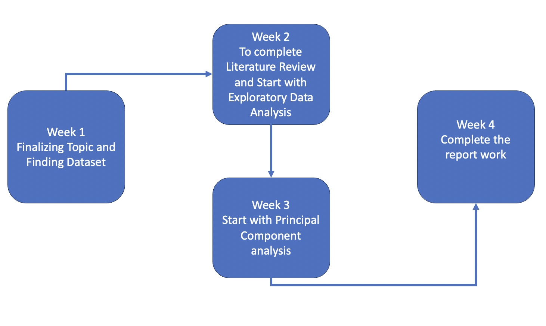

Figure 2.1: Project Timeline

The timeline of the project consists of a duration of four weeks, so in first week, the main aim is to decide a topic, study about that topic, and find the right dataset that must be used in that project, thereafter, finalize the topic with the faculty guide’s approval.

In second week, there should be starting of reading near about five research paper on the same topic, and trying to draw a comparative study on how and why these methods of are finding the Spotify Songs Skip different from each other, what are the various ML Algorithms used in it and what are the different type of RS that are used in the previously studied projects. The aim of the different Research Papers. Also to start working on what Exploratory Data Analysis is, how can we draw the comparison of different parameters that are present in the model and how can it be explored more vastly in terms of the different parameters present in the Spotify Dataset.

In third week, we start with Data Wrangling. The method of transforming unusable facts into a useful form is known as data manipulation. Information munging and data cleanup are some names for it. When performing any kind of examination, one will normally undergo the data wrangle procedure to make that that the information is accurate and comprehensive.

Wrangling information can be done either manually or automatically. Automated data cleansing is essential in cases when datasets are very huge. A data researcher or another colleague is often in charge of data wrangle in businesses with a comprehensive data team. In the case of smaller companies, cleansing information for using it is frequently the job for non-data specialists.

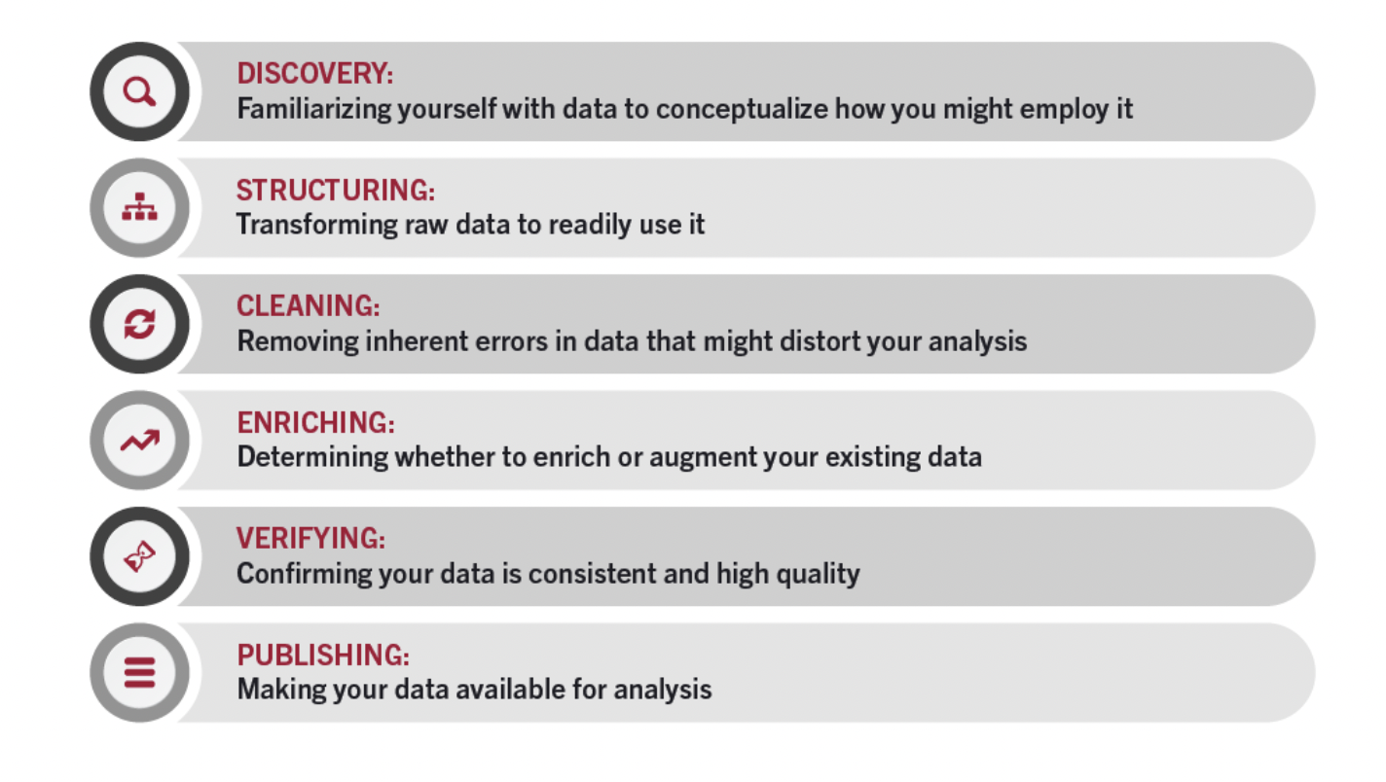

Figure 2.2: Steps in Data Wrangling [5]

**2.4.1 DISCOVERY**

The act of familiarising oneself with data so you may imagine how you could utilise it is known as exploration. It's comparable to checking the fridge to see which products we can get prior to preparing a dinner.

Throughout the procedure of discovery, one can identify trends or patterns in the data and also evident problems, like numbers which are absent or errors requiring being fixed.

**2.4.2 STRUCTURING**

Most of the time, missing or improperly structured basic info is unsuitable in what was meant by it. The act of collecting unprocessed information and converting it so that it may be used more easily is known as information architecture. Depending on the method of analysis you choose to understand the information, the information could take different forms.

**2.4.3 CLEANING**

Cleaning up information is the process of eliminating data's innate flaws, which might skew your research or make it useless. Various types of cleansing are possible, such as eliminating unused cells or columns, eliminating anomalies, and standardizing inputs. Making ensuring there aren't any errors—or just as few as probable—that can affect ultimate assessment is the aim of data cleaning. The remainder of the data wrangling operations are significantly impacted by locating and eliminating any inaccurate information.

**2.4.4 ENRICHING**

We must assess the extent to which you possess all the information needed to complete the task at issue after understanding the present knowledge and transforming the information into an improved useable version. Otherwise, one can opt to add values obtained from different collections to the own to enhance or supplement it.

**2.4.5 VERIFYING**

The technique of ensuring that your information is accurate, and uniform is known as validity of data. You can find problems in verification which you must correct or arrive at the conclusion that the information is prepared for analysis. Coding is needed to perform numerous computerized tasks that serve as verification.

**2.4.6 PUBLISHING**

One may release the information after is goes through validation. It entails having it accessible for study to others inside the organization. Its data as well as the mission of the organization will determine the medium that you employ to distribute the data, like a printed document nor a digital document.

**CHAPTER 3**

**LITERATURE REVIEW**

An usual element on websites like Spotify, Pinterest, YouTube, and Goodreads is personal curating. Viewers may compile collections using things including melodies, pictures, movies, even novels to offer a distinctive viewpoint on what might be organised altogether. Consumer-generated product listings are regularly developed, vetted, then administered on various sites for individuals. Customers often have identifying possible things, decide whether they belong on a list, add them, finally maybe continue to maintain the listing. Thereafter investigate the essential but difficult subject of consumer-generated product lists continuance in order to speed up the method and help users discover more appropriate things to put on listings.

Anyone can find millions of songs on Spotify, along with to other publications by writers across worldwide. Spotify is an app providing podcasts, videos on demand, and music. Simple activities like consuming audio are totally gratis, nevertheless the paid version of Spotify also provides a choice. No matter if your profile is a Member, one can still: Integrate your musical selections and radio libraries, get recommendations according to your interests, plus a lot more!

It can easily move among Spotify's supported systems, including computers, mobile phones, speakers, plasma screens, and cars. Youtube is one of the leading businesses in the marketplace for streaming audio. Since it was first made available to the public in 2008, Spotify has seen rapid expansion.

Mixtape creation and continuance automatically. Automated song-based playlists creation and continuance have been the subject of extensive earlier study, which is divided into three divisions. The initial area concentrates on neural networks that employ learning lineups like a collection generating music sequencing to estimate the possibility of an additional album. In one instance, Chen et al. [6] enhance the initial-order Markov Chain used by McFee et al. [7] with metrics embedded data to describe tracks.

The second type of process mostly uses sounds from songs to create alternative playlist. Some instances include along with in which Maillet et al. [8] training classifications to decide if a series of tracks may constitute a collection of songs. The third field is closest to our research since it frequently uses data mining or algorithms for recommendation to forecast the following N entries.

User-generated product listings are gaining a growing amount of attention lately. In order to understand the societal principles of user-generated product a list, Zhong et al. [9] investigate the reasons behind the act behind human curating. According to Feinberg et al. [10], who examined the properties of items charts, these exist two different types of listings: those utilised for managing private data as well as those used as a means of speech. The growing number of picture libraries on Twitter is examined by Lo et al. [11].

To improve personalised picture recommendations, Lu et al. [12] or Eksombatchai et al. [13] extract user preferences using Twitter picture-based lists. To suggest current product lists to consumers is an intriguing topic. He et al as colleagues [14] provide an organisational self-attentive paradigm for matching the proper people with produced by users topic lists.

Additionally, [15] proposes the List-Based Suggesting System for suggesting literature lists, while [16] proposes the Embed Factoring Model for promoting music soundtracks. The neural networks are currently used extensively in recommendations. He et al. [17] use generalised matrix factors and multiple perceptron layers for explicit top-k ranking. Neural nets are employed for recommendations by Ebesu et al. [18]. For session-based recommendations, Hidasi et al. [19] suggest a GRU-based method, while Tang et al. [20] suggest an CNN approach. In models, weighted-summing components are frequently implemented using attentiveness nets.

In a result, such lists ought to be automatically generated and continued, much as song-based plays [21]. Secondly the majority of conventional album extension research presupposes that playlists are consistently constant. With the sole instance of provided in beginning, the remaining instances are or, which suggest a group of songs with speed dispersion is as comparable with the present list as feasible [22,23,24]. Listing continuance techniques, nevertheless, must constantly adjust to such circumstances because we see that the uniformity for collections differs significantly between and among multiple platforms [25,26,27,28].

**CHAPTER 4**

**DATASET DESCRIPTION**

The principal objective of our research is to build an ordered skip prediction demonstration that can forecast whether or not a client would skip over a track based on the individual's familiarity with prior songs and the melodic features of the melody in a certain listening sessions [29].

Finding the type of audio an individual wants to listen for is currently a barrier for streaming artists. This research is focused on developing an orderly jump forecasting approach to determine whether the user would choose to skip over a specific section dependent on how the user interacted with prior lyrics and the lyrical attributes of the current track during a personal listening encounter. Determining when an episode will be heard or retained will constitute the outcome; the data being provided would be a combination of sound attributes and user behavior.

Table No 4.1: Dataset Description

|  |  |
| --- | --- |
| session_id | Once a person starts listening to music on spotify, at that present moment a session is created for that person, and it is referred to as session id. |
| session_length | The track's length in seconds. |
| skip_1 | If the tune only aired momentarily. |
| skip_2 | If just a little portion of the tune was listened to [30]/ |
| skip_3 | When the whole track was performed |
| not_skipped | The song that has not been skipped, and is played on Spotify Application without any pause. |
| context_switch | The song has been switched with some other song as soon as it is being played on the Spotify Application [31]. |
| no_pause_before_play | There is no pause before playing of the next song |
| short_pause_before_play | There is a short time duration of pause before listening to the next song [32]. |
| long_pause_before_play | There is a long time duration of pause before listening to the next song. |
| hour_of_day | It refers to the time of the day during which the song is played on the Spotify Application |
| date | The date of the year on which the song is played |
| release_year | The year on which the song is released |
| us_popularity_estimate | The track's success. The range of the value will be 0 to 100, with 100 being the most common figure. It is determined by a formula and mostly depends on when it was released and how many times the song is being played overall. In broad terms, songs which are performed often currently will be more common in comparison to those that have been performed often in earlier times. The theoretical connection between song success and musician and lp success. Because the number doesn't change in immediate fashion, the recognition number could be behind real reputation by a few weeks [33] |
| acousticness | A scale from 0.0 to 1.0 showing how definite it is that the beat may be heard. 1.0 indicates a high degree of confidence in the acoustical properties of the outermost layer [34]. |
| beat_strength | This determines how strong is the beat of the song that is being played, usually the first beat is the strongest and the third beat Is the weakest [35]. |
| bounciness | Any song's bounciness is determined by an assortment of musical variables, like pace, beat security, pulse intensity, or general consistency. The lowest enjoyable number is 0.0, while the highest enjoyable number is 1 [36]. |
| danceability | Any song's danceability is determined by an assortment of musical variables, like pace, beat security, pulse intensity, or general consistency. The lowest enjoyable number is 0.0, while the highest enjoyable number is 1 [37]. |
| energy | The subjective gauge of strength and action, vitality can range from 0.0 to 1.0. In general, frenetic music seems quick, loud, very boisterous. In this respect, a Bach prelude rates poorly on the intensity scale compared to thrash rock. The aforementioned attribute is influenced by sensory elements including range of motion, observed loudness, tone, start percentage, and generalised unpredictability [38]. |
| instrumentalness | It determines if a music is vocal-free. Voices like "ooh" or "aah" are seen as essential in the present scenario. Obviously "vocal" tracks include speech or rap. The chance that an opus is vocal-free increases when the instrumentalness value approaches 1.0. The purpose is for numbers over 0.5 to suggest orchestral recordings, although certainty increases as the total number gets nearer to 1.0 [39] |
| key | The course's assessed total grade. Using the common Tone Category note-taking, numbers correspond to pitch. For instance, 0 = C, 1 = C/D, 2, and so on. Result -1 is returned if no key was found [40] |
| liveness | Identifies whether there is a listenership in the recording. Greater vitality numbers indicate a greater probability of the song was played live. A score greater than 0.8 indicates a high probability if the sound is active. The outcomes under this characteristic are distributed as follows: a dispersion of life [41]. |
| loudness | Decibels as or volume, of the music altogether [42]. When trying to compare a pair of paths, decibel ratings are summed throughout the whole track. The characteristic noise that most closely resembles tangible strength (amplitude) is volume. The usual ranges are around -60 to 0 db. |
| mode | The track's key (major or low) identifies the sort of pitch that is used when its rhythmic material is formed [43]. Minimal is denoted by 0, whereas big is symbolised by 1. |
| speechiness | Speechiness is a feature that recognises phrases used in music. Its value will be nearer to 1.0 depending on how strictly speech-like the sound file is (such as a television programme, audible publication, or piece of literature) [44]. Songs which are most likely formed completely of phrases spoken have values over 0.66. Songs which may include audio and voice, in single portions or multifaceted, are described by ratings around 0.33 through 0.66, encompassing situations like music from rap artists [45]. Values less than 0.33 probably refer to recordings that are not speech-like, like tunes. |
| tempo | The approximate beats per minute (BPM) pace for a piece of music as a whole [46]. Tempo, which in musical terms refers to a piece's movement or rhythm, is inextricably linked to the length on an ordinary beating. |
| Acoustic_Vectors | A scale of 0.0 to 1.0 indicating the degree of certainty that the rhythm is audible. 1.0 denotes an elevated level of assurance that the surface is acoustical [47]. |
| valence | A scale between 0.0 to 1.0 used to describe the overall melodic positivity of a tune. Higher valance recordings seem happier, whereas low valance recordings seem darker in tone [48]. |

**CHAPTER 5**

**METHODOLOGY**

Figure 5.1: Methodology

**5.1 DATA PREPROCESSING**

For the study conducted,  using the Spotify Sequential Skip Predictions information set, whose is made up of over 130 billion hearing session. There are 20 maximum songs in a single session. During the initial portion of an a meeting, all user behaviour characteristics and record identities were supplied; however, for the subsequent fifty percent, just the path identities will be given [49]. The song's ids are linked to acoustics aspects of the tune that may be retrieved through the Spotify API. The consumer's behaviour characteristics include activities such pausing, time of day, etc., whereas the sounds are information like danceability, pace, etc [50].

**5.2 EDA ANALYSIS**

EDA, encompassing aspects like managing values that are absent, interpreting times, and resolving irregular entry of information, makes up the approach to data management. Actual data typically includes vibration, values that aren't present, nor could come presented in an undesirable design, making it impossible to build models based on ML on it immediately [51]. EDA is necessary to purify it up and prepare it to be used in a model that uses ML, it also improves its precision and effectiveness.

A number of improvements occurred during this phase:

1. Screening for missing values

2. Combining data-sets .

3. Date encoding

4. Remove the numbers and category values within the data-set [52].

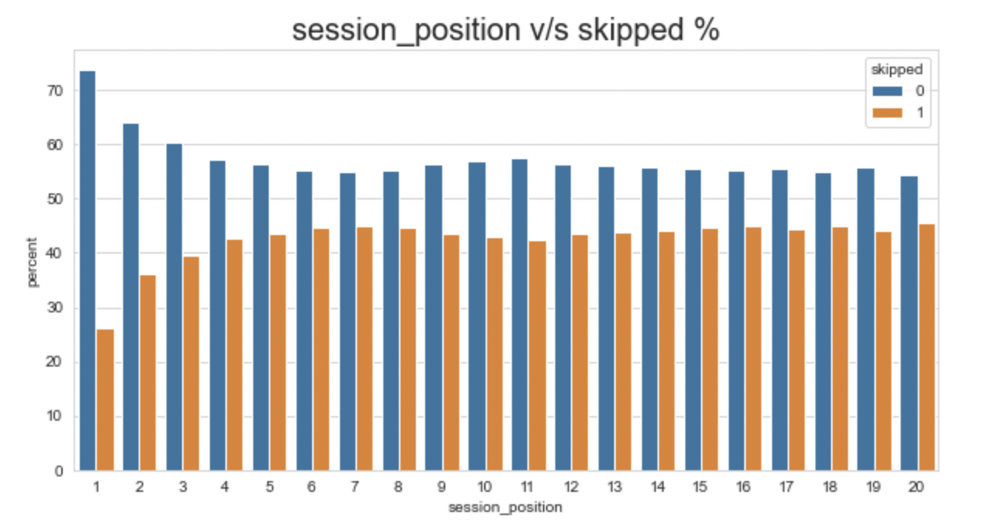

Figure 5.2: Session_position v/s skipped %

Figure 5.2, indicate the Session_position v/s skipped %, and how it can be shown on a scale percentage of 0-100, and the session position denoting from 1 to 20.

Figure 5.3: Session_length v/s skipped %

Figure 5.3, indicate the Session_length v/s skipped %, and how it can be shown on a scale percentage of 0-100, and the session length denoting from 10 to 20.

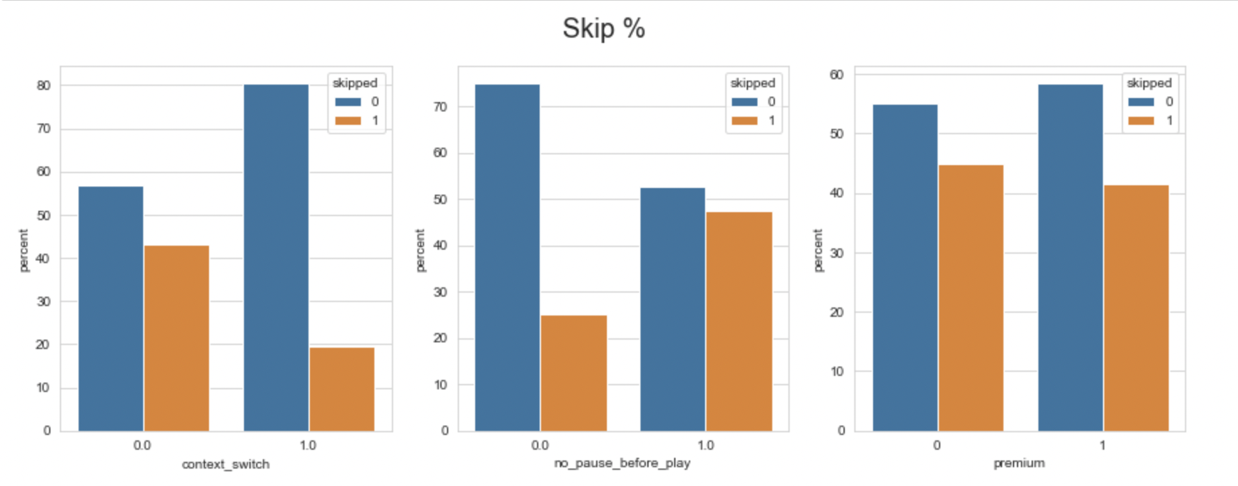

Figure 5.4: Skip%

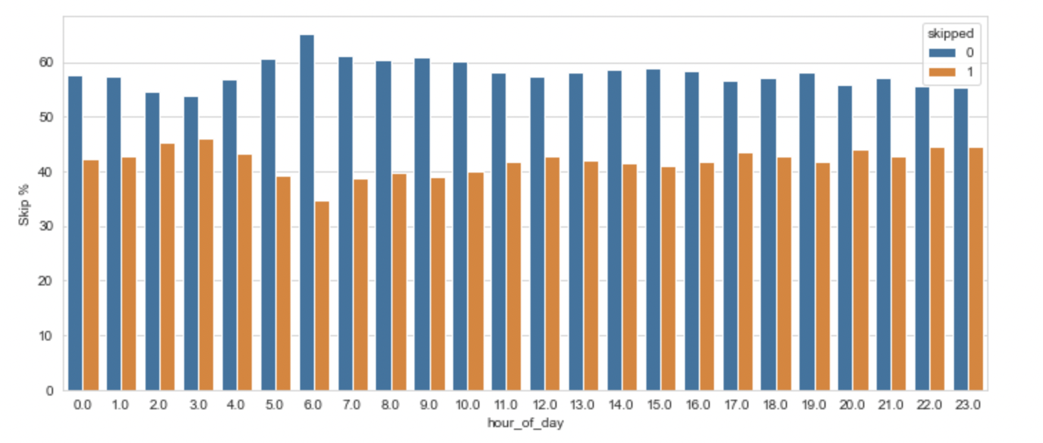

Figure 5.5: Skip% vs Hour_of_day

Figure 5.5, indicates the Skip% vs Hour_of_day , and how it can be shown on a scale percentage of 0-100, and the hour_of_day denoting from 0 to 23.

Figure 5.6: Skip% vs Release_year

In Figure 5.6, it is showing the percentage of skips with respect to the release in year. In the dataset, we can show the songs that were release in the year 1950 to the year 2018, and with respect to the year of release, a corresponding data of whether a person will skip the song thinking its old or its too new can be shown in this graph.

**5.3 TRAINING MODEL**

Figure 5.7: Model Training Parameters

Key objective of training models is the creation of a model that has been trained, which simplifies renowned to new familiar to unidentified information.

For the instruction set, around 130 billion listens with tens to twenty recordings apiece were made available [53].

The sample set included about thirty million auditory meetings, including full information available regarding every session's first forty minutes plus predictions for every session's finale. Just ten thousand bouts of data were sampled for this research, with halves of every session's recordings being used to teach & halves for test [54]. Data were split between two major files, the first of which contains interaction characteristics for the tune in 22 posts, such as the time of day, the duration for the time of year, the kind of setting, and past user conduct [55].

**5.4 TEST MODEL & EVALUATION**

Figure 5.8: Confusion Matrix

The parameters 'beat_strength', 'bounciness', 'danceability', and 'dyn_range_mean' are substantially related to one another in the hotspot displayed. Bounciness and Dynamic Ranging Mean had the greatest Pearson correlation (0.012) to the goal factor "skipped" out of these Four factors [56]. However, "bounciness" has a total of association to other factors of 2.81 and "dyn_range_mean" has a sum of association to related factors of 0.89, 0.89, while 0.82, respectively. Thus, it will preserve "bounciness" while remove "beat_strength," "danceability," and "dyn_range_mean" [57].

**5.5 MODEL PREDICTION**

**5.5.1 RANDOM FOREST CLASSIFIER**

Prominent ML technique RF is a part of the supervised-learning methodology. It may be applied to ML issues involving regression along with classification [58]. It is built upon the idea of collaborative learning, meaning a method of integrating numerous classifiers to address difficult issues and enhance the efficiency of the models [59].

**5.5.2 XGB CLASSIFIER**

XGBoost is is a global gradient-booster package that has been optimised for quick and scalability neural network building. A number of weaker models' forecasts are combined using this approach of ensemble-learning to get a more powerful estimate [60]. Extreme-gradient enhancement, is one of the most commonly utilised ML algorithms because it can manage enormous data-sets while remaining at the cutting edge in many applications of ML like predicting and predicting [61].

**5.5.3 DECISION TREE CLASSIFIER**

A method called a DT may be employed to address problems with regressions and classifications, but it is often favoured for doing so. It consists of the classifier based on a tree-structure, whereby inside vertices stand in for a dataset's characteristics, branching for the decision-making process, and all of leaf-nodes for the sorting result [62].

**5.5.4 K NEAREST NEIGHBOURS**

Another among the simplest ML method, is K-Nearest Neighbour. The K-NN method makes a claim which the newly created scenario therefore the existing cases are comparable, and it places the fresh instance in the category that is most like what is currently available.

**5.5.5 LOGISTIC REGRESSION**

Arguably the more well-known ML methods, within the field of supervised-learning, is LR. A collection of distinct variables are utilised to forecast the category factor that depends utilising this method [63].

**5.5.6 SUPPORT VECTOR MACHINE**

Among the more well-liked supervised-learning SVM, is utilised to solve Classifier and Forecasting issues. Yet, it is largely employed in ML Classifier issues. The objective of the SVM methods is to establish the optimal vector or judgement border that divides space of n-dimensions into courses, allowing us to swiftly categorise new information in the near future. The term hyper-plane is the name given to the aforementioned optimal judgement limit [64].

**CHAPTER 6**

**RESULT**

**6.1 RANDOM FOREST CLASSIFIER**

Figure 6.1: Random Forest

In Figure 6.1, we can see that, the accuracy for Random Forest Classifier is coming out to be 86.09%. Prominent ML method Random Forest Classifier often gets employed for categorization jobs. It is a member that a group from methods known as ensemble-learning, that integrates the forecasts of several standalone models into a single ultimate forecast. The resilience, adaptability, and capacity for handling enormous or intricate information are hallmarks of the RF method [65].

**6.2 XGB CLASSIFIER**

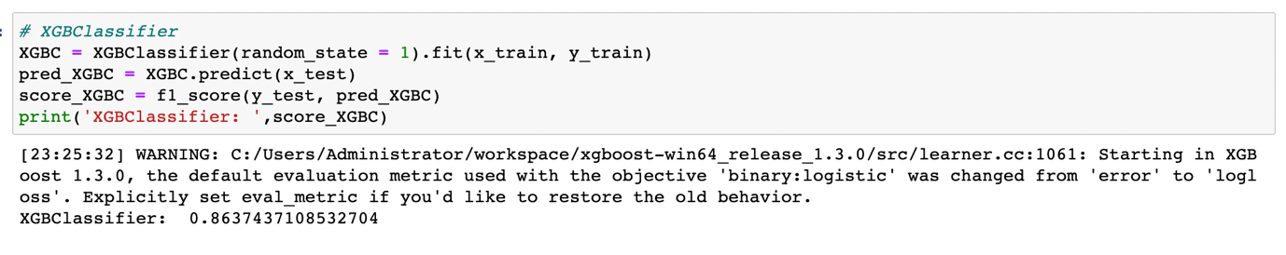Figure 6.2: XGB Classifier

In Figure 6.2, we can see that, the accuracy for XGB Classifier is coming out to be 86.374%. It represents a well-known ML technique from the lineage of gradient-boosts. It has a reputation as having been effective, scalable, and highly accurate [66]. XGBoost is one of strongest and widely utilised methods in ML contests and practical uses because it blends the strength of gradient-enhancement alongside a number of improvements.

**6.3 DECISION TREE CLASSIFIER**

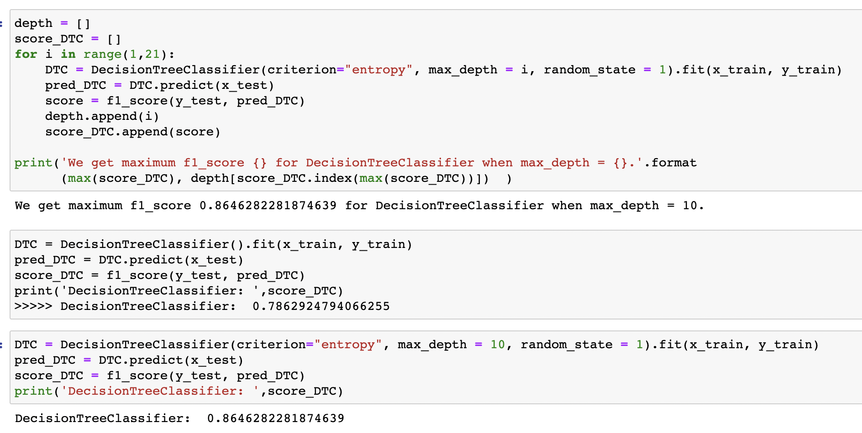Figure 6.3: Decision Tree Classifier

A well-liked ML approach called a DT is frequently employed for problems involving regression as well as classification. It offers a basic but effective approach that builds a framework like a diagram to simulate how people form judgements. A series of if-then criteria are used to divide the feature pool in the selection tree method. The leafy nodes of the structure reflect the end result or conclusion, whereas every interned node reflects a judgement made on a particular attribute. The DT approach divides the data into tiered chunks according to the chosen characteristics, with each split seeking to maximise the amount of information or reduce contamination. The DT Accuracy came out to be nearly 86.46% with the maximum f1_score is 0.8646 for DT Classifier when the maximum depth is equivalent to 10 [67].

**6.4 K-NEAREST NEIGHBOURS**

A well-liked ML approach for tackling regression and classification issues is called KNN. This is an indirect approach that bases its forecasts on the attribute space's KNN [68]. The gap among a request example and every example for training is calculated through the KNN Classifier. Then, depending on the smallest separation, the k closest neighbours are determined. In Figure 6.4, KNN Classifier accuracy comes out to be 86.46%.

Figure 6.4: KNN

**6.5 LOGISTIC REGRESSION**

Figure 6.5: Logistic Regression

LR issues are frequently solved using a mathematical modelling approach known as LR. It is not a kind of regression method, unlike its title, but an identification method. Utilising a logistic function, a LR model calculates the likelihood that a specific case belongs to a given category. The Accuracy for LR came out to be 85.39%.

**6.6 SUPPORT VECTOR MACHINE**

A sophisticated and adaptable ML method called SVM is employed for both regression as well as classification applications. Through maximising the margin between the various courses, SVM seeks to identify the best hyper-plane for dividing distinct classes or for making predictions based on ongoing values [69]. The method does this by transforming the information into a more complex field space and searching for the hyper-plane that is farthest form the closest points in every set of information. In Figure 6.6, the accuracy for Support Vector Machine came out to me 85.91%.

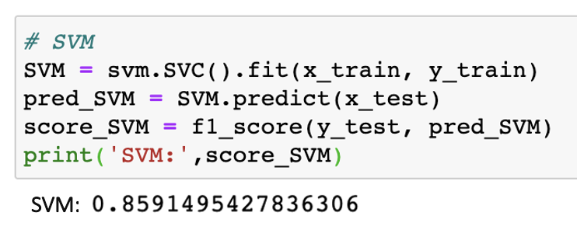

Figure 6.6: Support Vector Machine

**CHAPTER 7**

**CONCLUSION**

In a nutshell the ability to bypass tracks on Spotify has completely changed how we listened to audio by giving buyers more freedom to customise and regulate their musical experiences. Participants may easily switch between tracks by tapping or clicking, which enables users to fast discover different categories, performers, or emotions. By enabling users to create custom individual and find fresh songs that matches their tastes, this capability has improved their encounter.

The launch of track bypassing on Spotify is having a significant effect on the entire musical business. With the knowledge that listeners may quickly go on to the next track even if they are not instantly engaged, musicians are given the chance to present their musical creations to a broader audience. Furthermore, song skimming has changed how listening to audio and has given us the flexibility to adjust musical preferences to various settings and scenarios [70]. With Spotify's track skipped function, it can easily create mixes that respond to our constantly shifting wants and tastes, either they're in the market for an energising track throughout an exercise session or a calming song after sleep.

Although music bypassing gives us a great deal of flexibility and option, it may also make it difficult for us to completely appreciate and interact with a song. It can miss undiscovered jewels or miss to understand the intended narrative or emotional trip which a creator had painstakingly built in their search for rapid satisfaction.

**REFERENCES**

[1] Geoffray Bonnin and Dietmar Jannach. 2015. Automated generation of music playlists: Survey and experiments. ACM Computing Surveys (CSUR) (2015).

[2] Da Cao, Xiangnan He, Lianhai Miao, Yahui An, Chao Yang, and Richang Hong. 2018. Attentive group recommendation. In SIGIR.

[3] Da Cao, Liqiang Nie, Xiangnan He, Xiaochi Wei, Shunzhi Zhu, and Tat-Seng Chua. 2017. Embedding factorization models for jointly recommending items and user generated lists. In SIGIR.

[4] Ching-Wei Chen, Paul Lamere, Markus Schedl, and Hamed Zamani.

[5] https://online.hbs.edu/blog/post/data-wrangling

[6] Shuo Chen, Josh L Moore, Douglas Turnbull, and Thorsten Joachims. 2012. Playlist prediction via metric embedding.

[7] Brian McFee and Gert RG Lanckriet. 2011. The Natural Language of Playlists. In ISMIR, Vol. 11. 537–541

[8] François Maillet, Douglas Eck, Guillaume Desjardins, Paul Lamere, et al. 2009. Steerable Playlist Generation by Learning Song Similarity from Radio Station Playlists. In ISMIR. 345–350.

[9] Changtao Zhong, Sunil Shah, Karthik Sundaravadivelan, and Nishanth Sastry. 2013. Sharing the loves: Understanding the how and why of online content curation. In Seventh International AAAI Conference on Weblogs and social media.

[10] Melanie Feinberg, Gary Geisler, Eryn Whitworth, and Emily Clark. 2012. Understanding personal digital collections: an interdisciplinary exploration. In Proceedings of the Designing Interactive Systems Conference. ACM, 200–209.

[11] Caroline Lo, Justin Cheng, and Jure Leskovec. 2017. Understanding online collection growth over time: A case study of Pinterest.

[12] Yuchen Liu, Dmitry Chechik, and Junghoo Cho. 2016. Power of Human Curation in Recommendation System.

[13] Chantat Eksombatchai, Pranav Jindal, Jerry Zitao Liu, Yuchen Liu, Rahul Sharma, Charles Sugnet, Mark Ulrich, and Jure Leskovec. 2018. Pixie: A system for recommending 3+ billion items to 200+ million users in real-time.

[14] Yun He, Jianling Wang, Wei Niu, and James Caverlee. 2019. A Hierarchical SelfAttentive Model for Recommending User-Generated Item Lists. In Proceedings of the 28th ACM International Conference on Information and Knowledge Management. ACM, 1481–1490.

[15] Xiangnan He, Lizi Liao, Hanwang Zhang, Liqiang Nie, Xia Hu, and Tat-Seng Chua. 2017. Neural collaborative filtering.

[16] Balázs Hidasi, Alexandros Karatzoglou, Linas Baltrunas, and Domonkos Tikk. 2015. Session-based recommendations with recurrent neural networks. arXiv preprint arXiv:1511.06939 (2015).

[17] Jiaxi Tang and Ke Wang. 2018. Personalized top-n sequential recommendation via convolutional sequence embedding.

[18] Jingyuan Chen, Hanwang Zhang, Xiangnan He, Liqiang Nie, Wei Liu, and TatSeng Chua. 2017. Attentive collaborative filtering: Multimedia recommendation with item-and component-level attention.

[19] Xiaowen Huang, Shengsheng Qian, Quan Fang, Jitao Sang, and Changsheng Xu. 2018. CSAN: Contextual Self-Attention Network for User Sequential Recommendation.

[20] Wang-Cheng Kang and Julian McAuley. 2018. Self-Attentive Sequential Recommendation.

[21] Brian Brost, Rishabh Mehrotra, and Tristan Jehan. 2019. The Music Streaming Sessions Dataset. In Proceedings of the 2019 Web Conference. ACM.

[22] Junyoung Chung, Kyle Kastner, Laurent Dinh, Kratarth Goel, Aaron C Courville, and Yoshua Bengio. 2015. A recurrent latent variable model for sequential data. In Advances in neural information processing systems. 2980–2988.

[23] Yoav Freund and Robert E Schapire. 1997. A Decision-Theoretic Generalization of On-Line Learning and an Application to Boosting. J. Comput. Syst. Sci. 55, 1 (Aug. 1997), 119–139.

[24] Sepp Hochreiter and Jürgen Schmidhuber. 1997. Long short-term memory. Neural computation 9, 8 (1997), 1735–1780. [5] Tomas Mikolov, Kai Chen, Greg Corrado, and Jeffrey Dean. 2013. Efficient estimation of word representations in vector space. arXiv preprint arXiv:1301.3781 (2013).

[26] Kay I Penny. 1996. Appropriate critical values when testing for a single multivariate outlier by using the Mahalanobis distance. Journal of the Royal Statistical Society: Series C (Applied Statistics) 45, 1 (1996), 73–81.

[27] Pascal Vincent, Hugo Larochelle, Yoshua Bengio, and Pierre-Antoine Manzagol. 2008. Extracting and composing robust features with denoising autoencoders. In Proceedings of the 25th international conference on Machine learning. ACM, 1096–1103.

Cantador I, Cremonesi P (2014) Tutorial on cross-domain recom-

mender systems. In: Proceedings of the 8th ACM conference on

recommender systems, RecSys’14. ACM, New York, NY, USA,

pp 401–402. https://doi.org/10.1145/2645710.2645777

29. Cantador I, Fernández-Tobías I, Berkovsky S, Cremonesi P (2015)

Cross-domain recommender systems. Springer, Boston, pp 919–

959. https://doi.org/10.1007/978-1-4899-7637-6_27

30. Carenini G, Smith J, Poole D (2003) Towards more conversational

and collaborative recommender systems. In: Proceedings of the

8th international conference on intelligent user interfaces, IUI’03.

ACM, New York, NY, USA, pp. 12–18. https:// doi.org/10.1145/

604045.604052

31. Cebrián T, Planagumà M, Villegas P, Amatriain X (2010) Music

recommendations with temporal context awareness. In: Pro-

ceedings of the 4th ACM conference on recommender systems

(RecSys), Barcelona, Spain

Cantador I, Cremonesi P (2014) Tutorial on cross-domain recom-

mender systems. In: Proceedings of the 8th ACM conference on

recommender systems, RecSys’14. ACM, New York, NY, USA,

pp 401–402. https://doi.org/10.1145/2645710.2645777

29. Cantador I, Fernández-Tobías I, Berkovsky S, Cremonesi P (2015)

Cross-domain recommender systems. Springer, Boston, pp 919–

959. https://doi.org/10.1007/978-1-4899-7637-6_27

30. Carenini G, Smith J, Poole D (2003) Towards more conversational

and collaborative recommender systems. In: Proceedings of the

8th international conference on intelligent user interfaces, IUI’03.

ACM, New York, NY, USA, pp. 12–18. https:// doi.org/10.1145/

604045.604052

31. Cebrián T, Planagumà M, Villegas P, Amatriain X (2010) Music

recommendations with temporal context awareness. In: Pro-

ceedings of the 4th ACM conference on recommender systems

(RecSys), Barcelona, Spain

Cantador I, Cremonesi P (2014) Tutorial on cross-domain recom-

mender systems. In: Proceedings of the 8th ACM conference on

recommender systems, RecSys’14. ACM, New York, NY, USA,

pp 401–402. https://doi.org/10.1145/2645710.2645777

29. Cantador I, Fernández-Tobías I, Berkovsky S, Cremonesi P (2015)

Cross-domain recommender systems. Springer, Boston, pp 919–

959. https://doi.org/10.1007/978-1-4899-7637-6_27

30. Carenini G, Smith J, Poole D (2003) Towards more conversational

and collaborative recommender systems. In: Proceedings of the

8th international conference on intelligent user interfaces, IUI’03.

ACM, New York, NY, USA, pp. 12–18. https:// doi.org/10.1145/

604045.604052

31. Cebrián T, Planagumà M, Villegas P, Amatriain X (2010) Music

recommendations with temporal context awareness. In: Pro-

ceedings of the 4th ACM conference on recommender systems

(RecSys), Barcelona, Spain

Cantador I, Cremonesi P (2014) Tutorial on cross-domain recom-

mender systems. In: Proceedings of the 8th ACM conference on

recommender systems, RecSys’14. ACM, New York, NY, USA,

pp 401–402. https://doi.org/10.1145/2645710.2645777

29. Cantador I, Fernández-Tobías I, Berkovsky S, Cremonesi P (2015)

Cross-domain recommender systems. Springer, Boston, pp 919–

959. https://doi.org/10.1007/978-1-4899-7637-6_27

30. Carenini G, Smith J, Poole D (2003) Towards more conversational

and collaborative recommender systems. In: Proceedings of the

8th international conference on intelligent user interfaces, IUI’03.

ACM, New York, NY, USA, pp. 12–18. https:// doi.org/10.1145/

604045.604052

31. Cebrián T, Planagumà M, Villegas P, Amatriain X (2010) Music

recommendations with temporal context awareness. In: Pro-

ceedings of the 4th ACM conference on recommender systems

(RecSys), Barcelona, Spain

[28] Stuart Cunningham, Stephen Caulder, and Vic Grout. 2008. Saturday Night or Fever? Context-Aware Music Playlists. In Proceedings of the 3rd International Audio Mostly Conference: Sound in Motion. Pitea, Sweden. ˚

[29] Sally Jo Cunningham, David Bainbridge, and Anne Falconer. 2006. ‘More of an Art than a Science’: Supporting the Creation of Playlists and Mixes. In Proceedings of the 7th International Conference on Music Information Retrieval (ISMIR). Victoria, BC, Canada.

[30] Sally Jo Cunningham, David Bainbridge, and Dana Mckay. 2007. Finding New Music: A Diary Study of Everyday Encounters with Novel Songs. In Proceedings of the 8th International Conference on Music Information Retrieval. Vienna, Austria, 83–88.

[31] Sally Jo Cunningham, J. Stephen Downie, and David Bainbridge. 2005. “e Pain, e Pain”: Modelling Music Information Behavior And e Songs We Hate. In Proceedings of the 6th International Conference on Music Information Retrieval (ISMIR 2005). London, UK, 474–477.

[32] L. Dey, M. U. Asad, N. Afroz, and R. P. D. Nath. 2014. Emotion extraction from real time chat messenger. In 2014 International Conference on Informatics, Electronics Vision (ICIEV). 1–5. DOI:hp://dx.doi.org/10.1109/ICIEV.2014.6850785

[33] Justin Donaldson. 2007. A Hybrid Social-acoustic Recommendation System for Popular Music. In Proceedings of the ACM Conference on Recommender Systems (RecSys). Minneapolis, MN, USA, 4.

[34] Gideon Dror, Noam Koenigstein, Yehuda Koren, and Markus Weimer. 2011. e yahoo! music dataset and kdd-cup’11. In Proceedings of the 2011 International Conference on KDD Cup 2011-Volume 18. JMLR. org, 3–18.

[35] Greg Dunn, Jurgen Wiersema, Jaap Ham, and Lora Aroyo. 2009. Evaluating Interface Variants on Personality Acquisition for Recommender Systems. In Proceedings of the 17th International Conference on User Modeling, Adaptation, and Personalization: formerly UM and AH (UMAP ’09). Springer-Verlag, Berlin, Heidelberg, 259–270.

[36] Shrey Dua and Hema A. Murthy. 2014. Discovering Typical Motifs of a Raga from One-Liners of Songs in Carnatic Music. In Proceedings of the 15th International Society for Music Information Retrieval Conference (ISMIR). Taipei, Taiwan, 397–402.

[37] Georgi Dzhambazov, Ajay Srinivasamurthy, Sertan S¸enturk, and Xavier Serra. ¨ 2016. On the Use of Note Onsets for Improved Lyrics-to-audio Alignment in Turkish Makam Music. In 17th International Society for Music Information Retrieval Conference (ISMIR 2016). New York, USA.

[38] Samira Ebrahimi Kahou, Vincent Michalski, Kishore Konda, Roland Memisevic, and Christopher Pal. 2015. Recurrent Neural Networks for Emotion Recognition in Video. In Proceedings of the 2015 ACM on International Conference on Multimodal Interaction (ICMI ’15). ACM, New York, NY, USA, 467–474.

[39] Hamid Eghbal-zadeh, Bernhard Lehner, Markus Schedl, and Gerhard Widmer. 2015. I-Vectors for Timbre-Based Music Similarity and Music Artist Classification. In Proceedings of the 16th International Society for Music Information Retrieval Conference (ISMIR). Malaga, Spain.

[40] Mehdi Elahi. 2011. Adaptive active learning in recommender systems. User Modeling, Adaption and Personalization (2011), 414–417.

[41] Mehdi Elahi, Mahias Braunhofer, Francesco Ricci, and Marko Tkalcic. 2013. Personality-based active learning for collaborative filtering recommender systems. In AI* IA 2013: Advances in Artificial Intelligence. Springer International Publishing, 360–371.

[42] Mehdi Elahi, Francesco Ricci, and Neil Rubens. 2014. Active Learning Strategies for Rating Elicitation in Collaborative Filtering: A System-wide Perspective. ACM Transactions on Intelligent Systems and Technology 5, 1, Article 13 (Jan. 2014), 33 pages.

[43] Mehdi Elahi, Francesco Ricci, and Neil Rubens. 2016. A survey of active learning in collaborative filtering recommender systems. Computer Science Review 20 (2016), 29–50.

[44] Asmaa Elbadrawy and George Karypis. 2015. User-specific feature-based similarity models for top-n recommendation of new items. ACM Transactions on Intelligent Systems and Technology (TIST) 6, 3 (2015), 33.

[45] Mehmet Erdal, Markus Kachele, and Friedhelm Schwenker. 2016. ¨ Emotion Recognition in Speech with Deep Learning Architectures. Springer International Publishing, Cham, 298–311. DOI:hp://dx.doi.org/10.1007/978-3-319-46182-3 25

[46] Ignacio Fernandez Tobias, Mahias Braunhofer, Mehdi Elahi, Francesco Ricci, and Cantador Ivan. 2016. Alleviating the New User Problem in Collaborative Filtering by Exploiting Personality Information. User Modeling and User-Adapted Interaction (UMUAI) 26, Personality in Personalized Systems (2016).

[47] Ignacio Fernandez-Tob ´ ´ıas, Ivan Cantador, Marius Kaminskas, and Francesco ´ Ricci. 2012. Cross-domain recommender systems: A survey of the state of the art. In Spanish Conference on Information Retrieval. 24.

[48] Bruce Ferwerda, Mark Graus, Andreu Vall, Marko Tkalciˇ c, and Markus Schedl. ˇ 2016. Influence of Users’ Personality Traits on Satisfaction and Aractiveness of Diversified Recommendation Lists. In Proceedings of the 4th Workshop on Emotions and Personality in Personalized Services (EMPIRE 2016). Boston, USA.

[49] Bruce Ferwerda and Markus Schedl. 2016. Investigating the Relationship Between Diversity in Music Consumption Behavior and Cultural Dimensions: A Cross-country Analysis. In Workshop on Surprise, Opposition, and Obstruction in Adaptive and Personalized Systems.

[50] Bruce Ferwerda, Markus Schedl, and Marko Tkalciˇ c. 2015. Personality & Emo- ˇ tional States: Understanding Usersfi Music Listening Needs. In Extended Proceedings of the 23rd International Conference

[51] Bruce Ferwerda, Andreu Vall, Marko Tkalciˇ c, and Markus Schedl. 2016. Exploring ˇ Music Diversity Needs Across Countries. In Proc. UMAP.

[52] Bruce Ferwerda, Emily Yang, Markus Schedl, and Marko Tkalciˇ c. 2015. Per- ˇ sonality Traits Predict Music Taxonomy Preferences. In ACM CHI ’15 Extended Abstracts on Human Factors in Computing Systems. Seoul, Republic of Korea.

[53] Arthur Flexer, Dominik Schnitzer, Martin Gasser, and Gerhard Widmer. 2008. Playlist Generation Using Start and End Songs. In Proceedings of the 9th International Conference on Music Information Retrieval (ISMIR). Philadelphia, PA, USA.

[54] Michael Gillhofer and Markus Schedl. 2015. Iron Maiden While Jogging, Debussy for Dinner? - An Analysis of Music Listening Behavior in Context. In Proceedings of the 21st International Conference on MultiMedia Modeling (MMM). Sydney, Australia.

[55] Samuel D Gosling, Peter J Rentfrow, and William B Swann Jr. 2003. A very brief measure of the Big-Five personality domains. Journal of Research in personality 37, 6 (2003), 504–528.

[56] Asela Gunawardana and Guy Shani. 2015. Evaluating Recommender Systems. In Recommender Systems Handbook (2nd ed.), Francesco Ricci, Lior Rokach, Bracha Shapira, and Paul B. Kantor (Eds.). Springer, Chapter 8, 256–308.

[57] Marc Hassenzahl. 2005. e ing and I: Understanding the Relationship Between User and Product. Springer Netherlands, Dordrecht, 31–42. DOI:hp://dx.doi. org/10.1007/1-4020-2967-5 4

[58] Jonathan L. Herlocker, Joseph A. Konstan, Loren G. Terveen, and John T. Riedl. 2004. Evaluating collaborative filtering recommender systems. ACM Trans. Inf. Syst. 22, 1 (2004), 5–53.

[59] Jonathan L. Herlocker, Joseph A. Konstan, Loren G. Terveen, and John T. Riedl. 2004. Evaluating Collaborative Filtering Recommender Systems. ACM Transactions on Information Systems 22, 1 (January 2004), 5–53.

[60] P. Herrera, Z. Resa, and M. Sordo. 2010. Rocking around the clock eight days a week: an exploration of temporal paerns of music listening. In Proceedings of the ACM Conference on Recommender Systems: Workshop on Music Recommendation and Discovery (WOMRAD 2010). 7–10.

[61] K. Hevner. 1935. Expression in Music: A Discussion of Experimental Studies and theories. Psychological Review 42 (March 1935). Issue 2.

[62] Rong Hu and Pearl Pu. 2009. A comparative user study on rating vs. personality quiz based preference elicitation methods. In Proceedings of the 14th international conference on Intelligent user interfaces (IUI ’09). ACM, New York, NY, USA, 367–372. DOI:hp://dx.doi.org/10.1145/1502650.1502702

[63] Rong Hu and Pearl Pu. 2010. A Study on User Perception of Personality-Based Recommender Systems.. In UMAP (2010-06-29) (Lecture Notes in Computer Science), Paul De Bra, Alfred Kobsa, and David N. Chin (Eds.), Vol. 6075. Springer, 291–302.

[64] Rong Hu and Pearl Pu. 2011. Enhancing collaborative filtering systems with personality information. In Proceedings of the fih ACM conference on Recommender systems (RecSys ’11). ACM, New York, NY, USA, 197–204. DOI:

[65] Xiao Hu and Jin Ha Lee. 2012. A Cross-cultural Study of Music Mood Perception Between American and Chinese Listeners. In Proc. ISMIR.

[66] Yifan Hu, Yehuda Koren, and Chris Volinsky. 2008. Collaborative filtering for implicit feedback datasets. In Proceedings of the 8th IEEE International Conference on Data Mining. IEEE, 263–272.

[67] Yajie Hu and Mitsunori Ogihara. 2011. NextOne Player: A Music Recommendation System Based on User Behavior. In Proceedings of the 12th International Society for Music Information Retrieval Conference (ISMIR 2011). Miami, FL, USA.

[68] A Huq, J.P. Bello, and R. Rowe. 2010. Automated Music Emotion Recognition: A Systematic Evaluation. Journal of New Music Research 39, 3 (November 2010), 227–244.

[69] Kalervo Jarvelin and Jaana Kek ¨ al¨ ainen. 2002. Cumulated gain-based evaluation ¨ of IR techniques. ACM Trans. Inf. Syst. 20, 4 (2002), 422–446.

[70] Oliver John and Sanjay Srivastava. 1999. e Big Five Trait Taxonomy: History, Measurement, and eoretical Perspectives. In Handbook of personality: eory and research (second ed.), Lawrence A Pervin and Oliver P John (Eds.). Number 510. Guilford Press, New York, 102–138.